Part 1:

How you made the changes



That the changes were made successfully



Part2:

The command that you used, include some output

screenshots from the man page for ps that illustrate how you

displayed the correct fields

sorted the output

Part3:

the commands that you use

to create your user



set your user's password

create a new group



change the group owner of the midterm directory



add your user to the group



evidence

how you found that man page

]

P4. Write a command that uses grep to find and print all the regular users on your system.

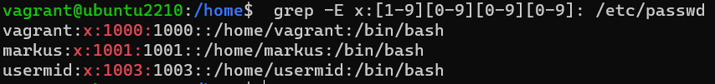

P5. 2 points Write a command, using find , that will find and count all the files in /etc . Hide all the error messages, “Permission denied”, by sending them to a file that doesn't store any data.



P6. 1point Run a command that will display the version of the kernel that your VM is using:

P7. 2 points Copy the code below into a new file $HOME/midterm/nfntlp . Make the file executable and run it as a background process, like this: ./nfntlp &

